PySpark

What is Spark: -

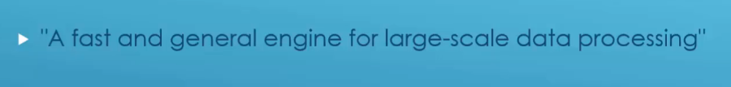

Spark Architecture: -

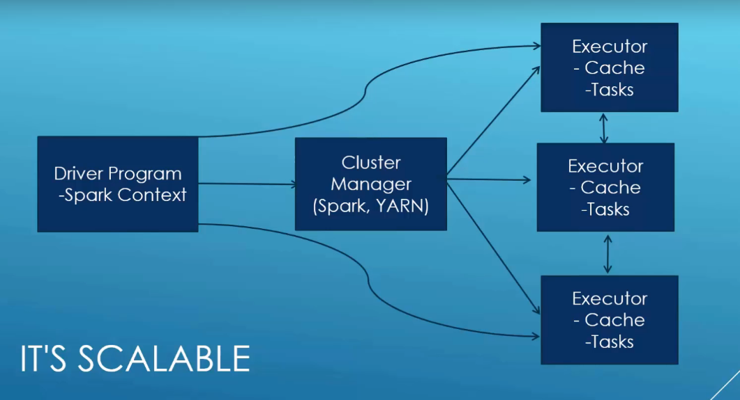

Why spark is fast: -

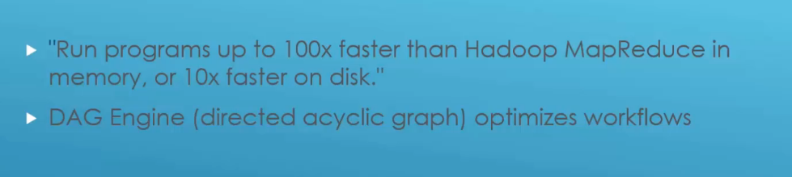

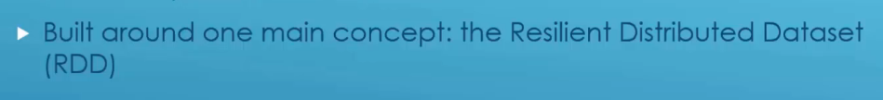

Spark Components: -

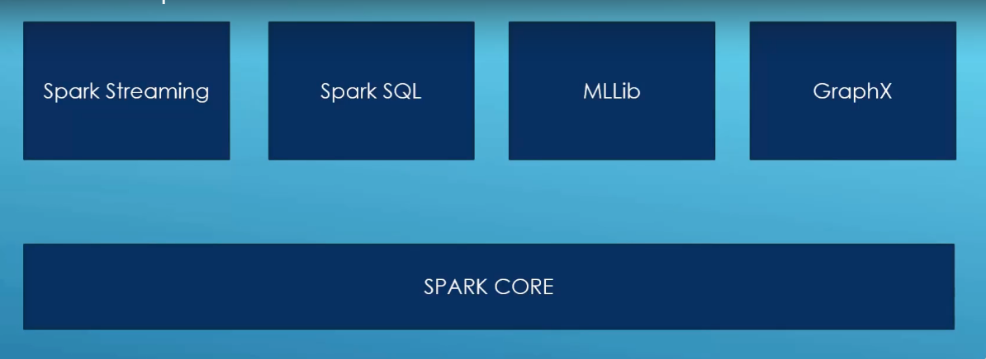

Introduction to RDD: -

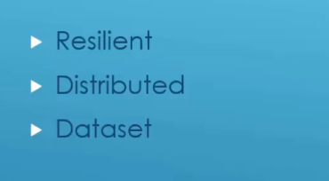

Spark Context: - Starting point of the spark framework

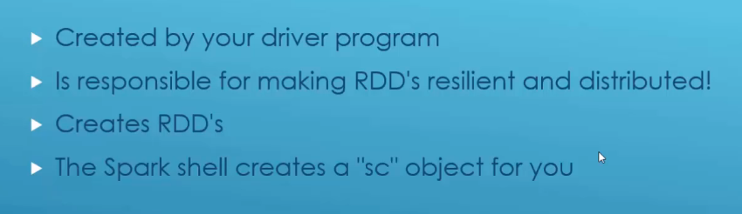

Creating RDDs: -

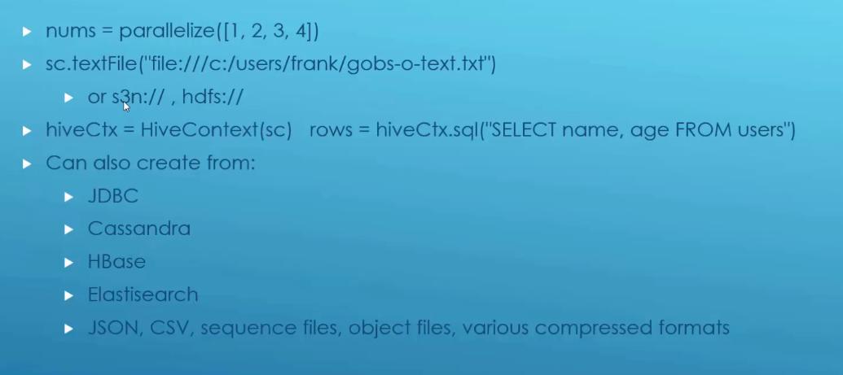

Common Transformation operations: -

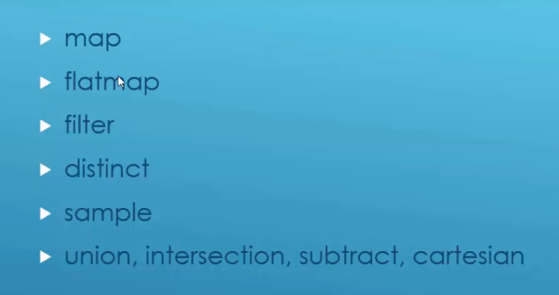

* Map – One to One relationship
* Flatmap – One to Many relationship

Map example: -

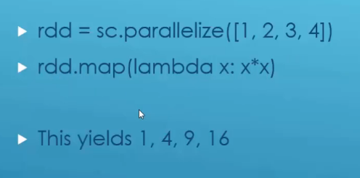

Some Actions: - Getting a result out of an RDD

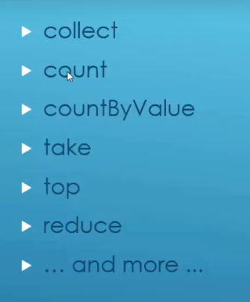

Lazy Evaluation: -

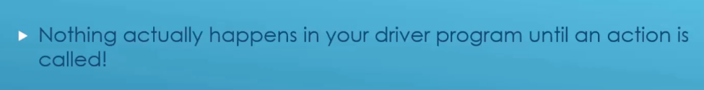

Ratings Histogram example: -

Import what we need: -

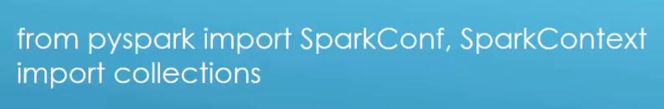

Set up our context: -

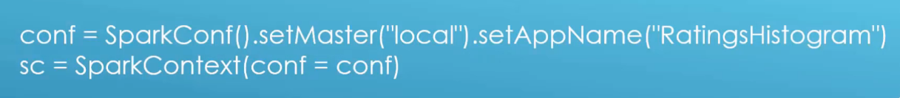

Our data: -

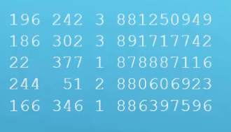

Loading the data: -



Extract the data we care about: -

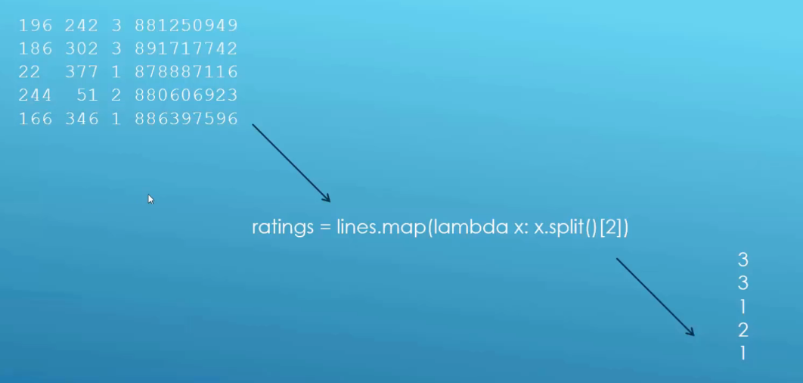

Performing an action: -

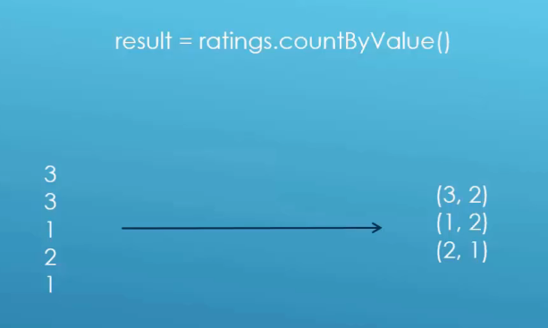

Sort and display the results: -

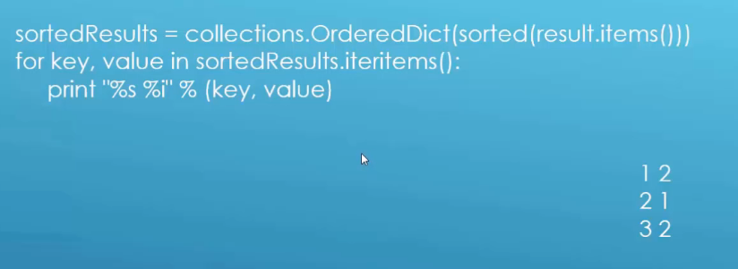

Ratings-counter: -

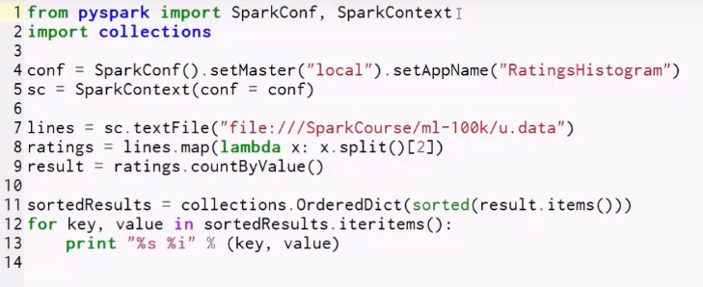

RDD’s can hold key/value pairs: -

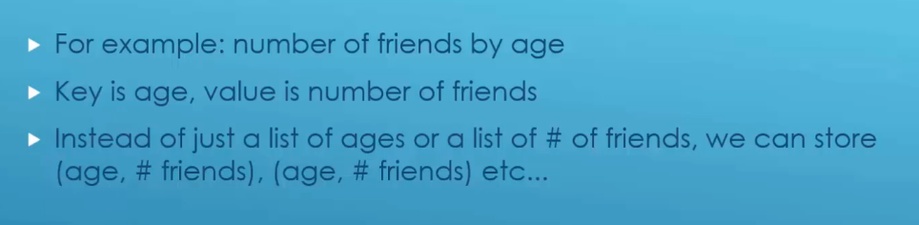

Creating a key/value RDD: -

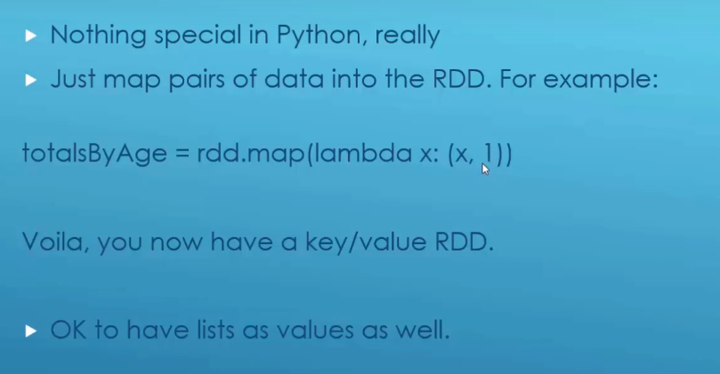

Spark can do special stuff with key/value data: -

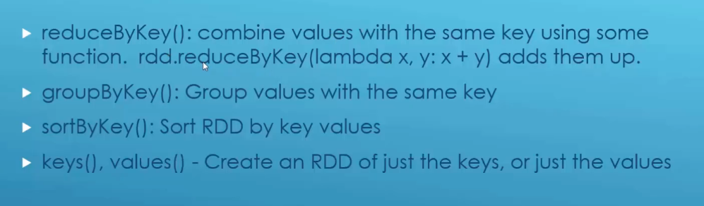

We can do SQL-Style joins on two key/value RDD’s: -

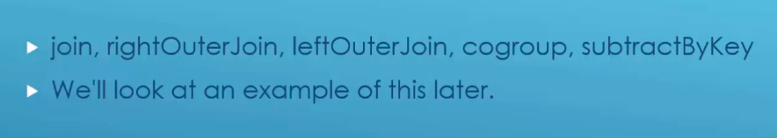

Mapping just the values of a key/value RDD’s: -

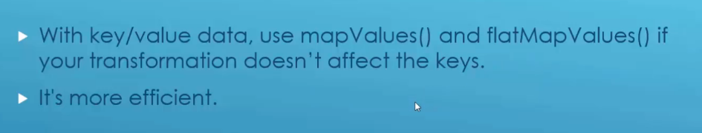

Average friends by age: -

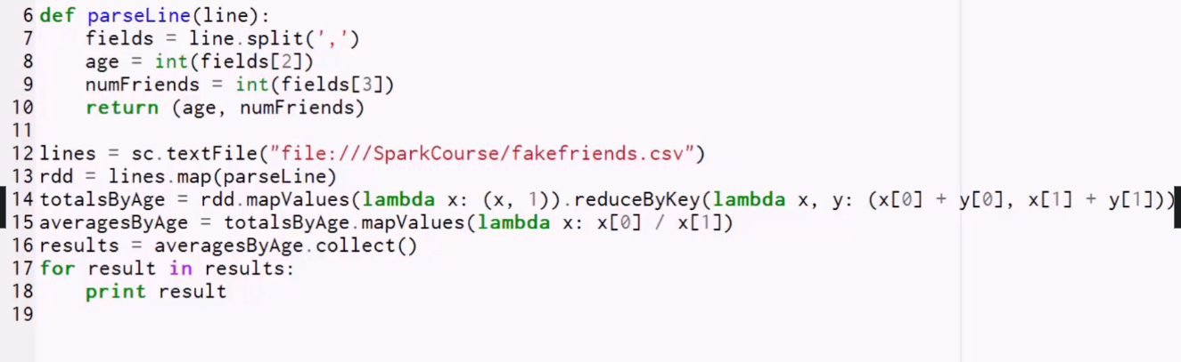

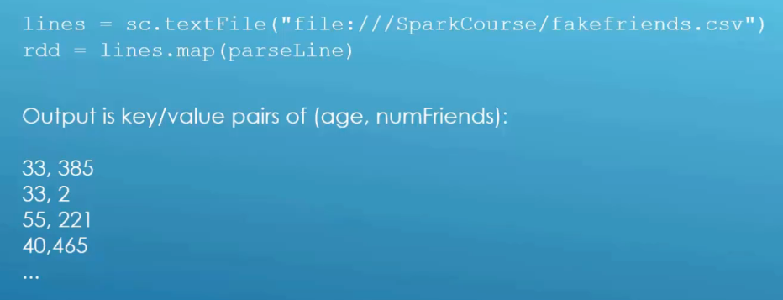

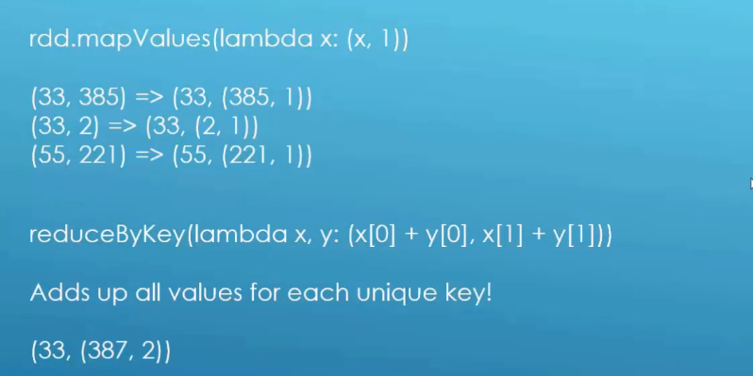

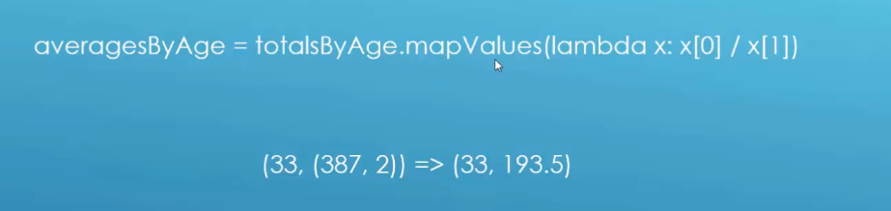

Filtering RDD’s: - Minimum Temperature Example

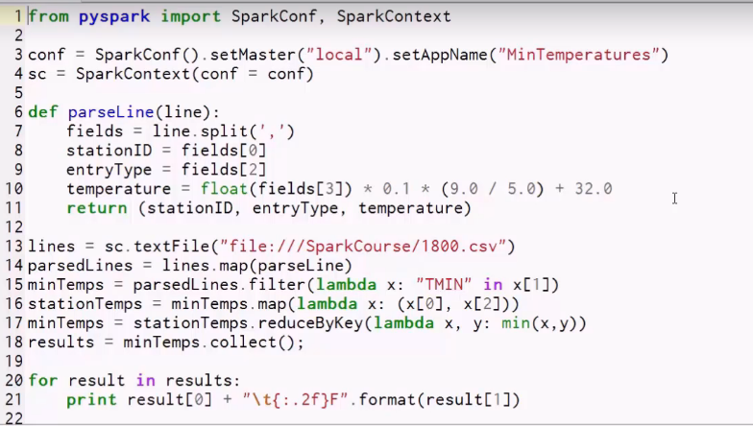

* Filter function accepts a Boolean function (returns True or False)
* If the output is True, it will keep the value otherwise discard it

Word count example: -

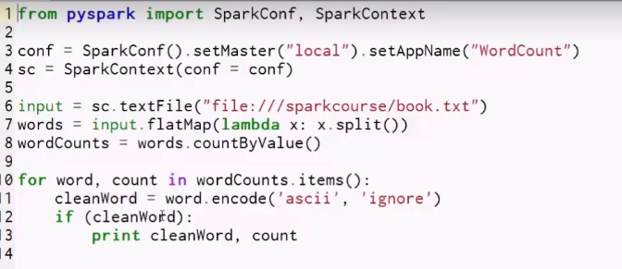

* Results are not really great
* Capitalizatin issues and special char issues etc

Word count better: -

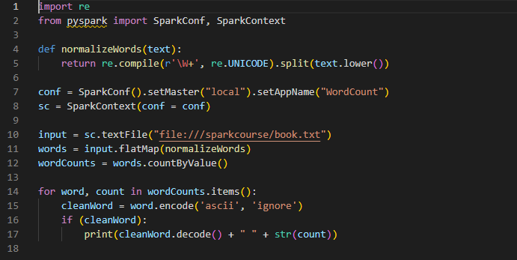

Word count better sorted: -

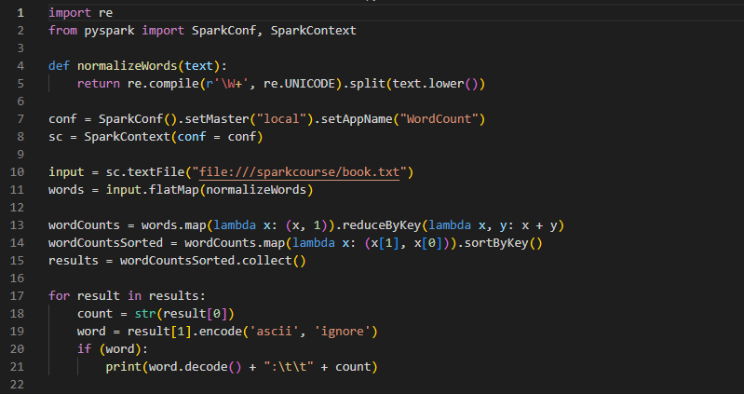

Dataframes: -

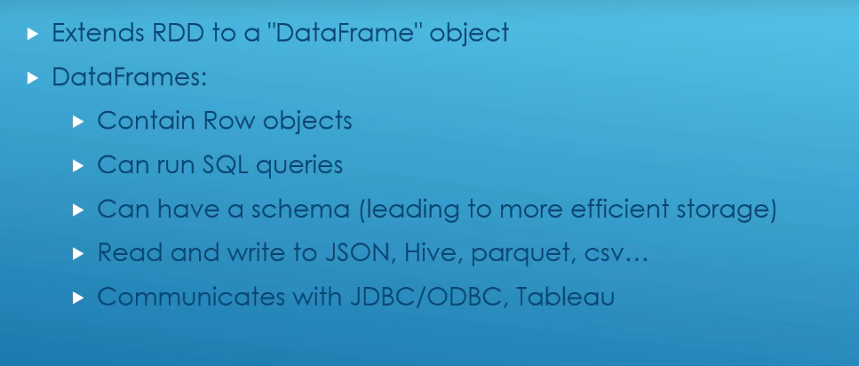

Using spark SQL in Python: -



Other stuff you can do with dataframes: -

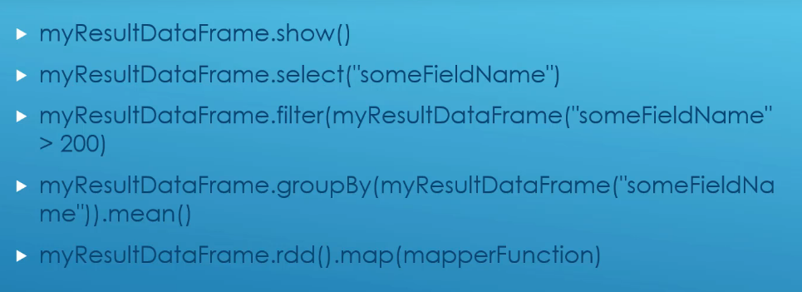

Dataframe are the new hotness: -

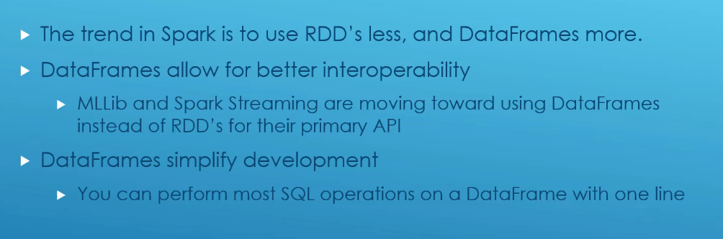

Dataframes vs Datasets: -

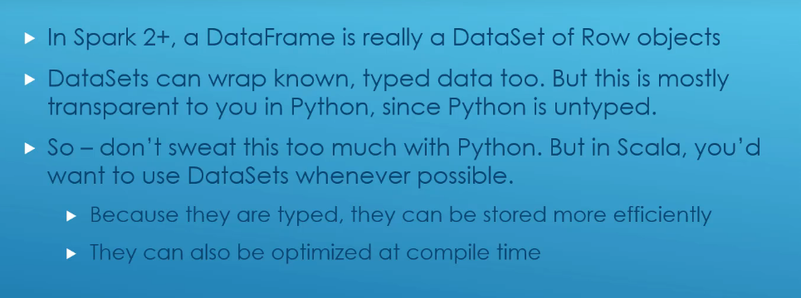

Shell access: -

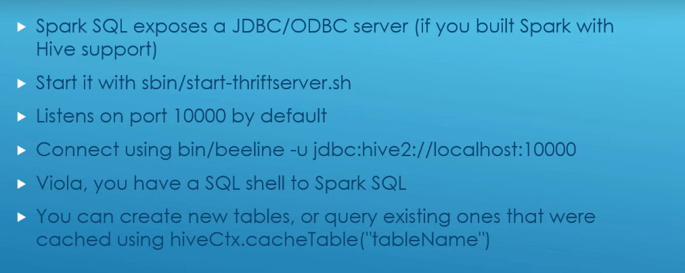

UDF’s in spark: -

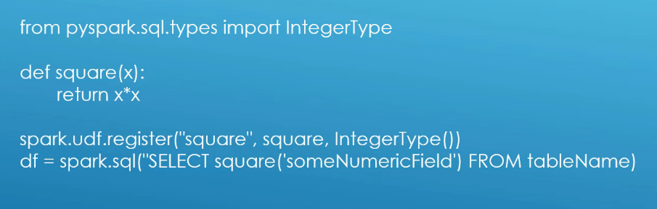

* You need to pass the data type the function will take as input